puzzle - Thumb Joystick

Introduction
puzzle - Thumb Joystick is a puzzle compatible module which is very similar to the 'analog' joystick on PS2 (PlayStation 2) controllers. The X and Y axes are two ~10k potentiometers which control 2D movement by generating analog signals. The joystick also has a push button that could be used for special applications. When the module is in working mode, it will output two analog values, representing two directions.Compared to a normal joystick, its output values are restricted to a smaller range (i.e. 200~800), only when being pressed that the X value will be set to 1023 and the MCU can detect the action of pressing.
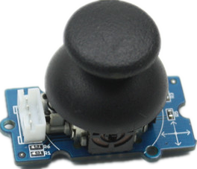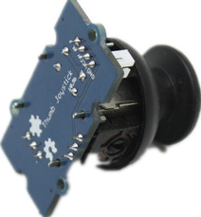
Features
- puzzle Interface
- 5V/3.3V Compatible
- Analog Output

Application Ideas
- Game Controller
- Robot remote
Specifications
Item | Min | Typical | Max | Unit
Working Voltage | 4.75 | 5.0 | 5.25 | V
Output Analog Value （X coordinate） | 206 | 516 | 798 | \
Output Analog Value （Y coordinate） | 203 | 507 | 797 | \
Usage
The puzzle - Thumb Joystick is an analog device that outputs analog signal ranging from 0 to 1023. That requires us to use the analog port of Arduino to take the readings.
1.Connect the module to the A0/A1 of puzzle - Basic Shield using the 4-pin puzzle cable.
2. Plug the puzzle - Basic Shield into Arduino.
3. Connect Arduino to PC by using a USB cable.

4.Copy and paste code below to a new Arduino sketch. Please click here if you do not know how to upload.

/*
Thumb Joystick demo v1.0
connec the module to A0&A1 for using;
*/

void setup() {
Serial.begin(9600);
}

void loop() {
int sensorValue1 = analogRead(A0);
int sensorValue2 = analogRead(A1);
Serial.print("The X and Y coordinate is:");
Serial.print(sensorValue1, DEC);
Serial.print(",");
Serial.println(sensorValue2, DEC);
Serial.println(" ");
delay(200);
}
5.You can check the values of the output analog signals by opening the Serial Monitor.

The output value from the analog port of Arduino can be converted to the corresponding resistance using the formula:R=(float)(1023-sensorValue)*10/sensorValue.

Resources
- puzzle-Thumb Joystick Eagle File

